Treasurer’s
Manual

FOR STUDENT ORGANIZATIONS

Compiled by OSU University Accounting

Updated May 2020

FOREWORD

Congratulations on your election to the office of treasurer of your organization. In accepting this position, you have assumed the responsibility of chief financial officer of the organization. You can best serve the membership of your organization by maintaining an accurate, organized and well-documented set of financial records. The Student Organization Treasurer’s Manual was prepared to assist you in fulfilling these objectives. Part of your responsibility as Treasurer is to advise members of your organization on the requirements contained in this manual prior to making transactions. This will greatly enhance the process by making sure the proper documentation is obtained.

The manual contains (i) step-by-step procedures for maintaining your financial records, (ii) procedures and example forms for processing deposits and payments through the University accounting system and (iii) instructions for reading your accounting reports. You should keep this manual with your financial records for future reference. If you have any questions after reading this manual, please contact the University Accounting office at 744-5881 (304 Whitehurst) or the Campus Life office at 744-5488 (211 Student Union). We look forward to working with you during your tenure of office.

This manual was prepared by the University Accounting office as a guide for treasurers of student organizations. At the date of publication, the information included in this manual was in compliance with the policies and procedures of the Office of Business and Finance of Oklahoma State University.



TABLE OF CONTENTS

Opening an Account 4

Tax Information for Student Organizations 5-6

Signature Card 7-8

Transaction Register 9-11

Deposits 12-16

Disbursement Vouchers 17-21

Campus Vendor Invoices 22

Gift Cards 23

Transfers and Donations 24

Accounting Reports 25-30

Account Reconciliation 31-34

Internal Audit Review 35

Purchasing Card Guidelines 36

OPENING AN ACCOUNT

Pursuant to Section XI, Conduct, Rights and Obligations of Student Organizations, in the Oklahoma State University statement of Student Rights and Responsibilities Governing Student Behavior, all funds of recognized student organizations must be kept on deposit with the University if obtained in any of the following ways:

a. Funds collected by the University on behalf of the club/organization.

b. Funds allocated by the University to the organization, including the Activity Fees Allocation Committee (AFAC) process.

If your organization meets the above criteria and does not have its funds on deposit with the University, you should contact the office of Campus Life at 744-5488 (211 Student Union) to open an account. At that time, your organization will be asked to execute an account signature card.

Upon request of the Director of Campus Life and receipt of your executed signature card, University Accounting will activate an account for your organization and notify your faculty advisor of your assigned fund code. The University does not charge a fee for maintaining your account.

Registered student organizations are not required to keep their funds on deposit
with the university but may do so if they desire. If they choose to open a bank account off campus, they will need to file IRS Form SS-4 to obtain a Federal Employer Identification (FEI) number. This number is required even though the student organization has no employees. Form SS-4 is available online at the IRS website (www.irs.gov). A copy of the SS-4 needs to be filed with the Campus Life Office at 211 Student Union.

Funds of those groups on deposit with the university may not be used to purchase
alcohol, beer or tobacco products. Likewise, student organizations are prohibited from using mandatory fees, dues, or assessments paid by members of the group to buy alcohol, beer or tobacco products.

TAX INFORMATION FOR STUDENT ORGANIZATIONS

Oklahoma State University Student Organizations are important to the general welfare and morale of the student body. However, the mission and purpose of each organization is unique to the interests of each group, and each group operates independently from the University while meeting certain University expectations.

Though affiliated with Oklahoma State University, student organizations operate under their own fiduciary requirements and follow business practices established under their own specific charters. As such, Oklahoma State University accepts no responsibility for federal or state tax requirements or liabilities incurred by student organizations.

Tax Exempt Status

There is a common misconception that Oklahoma State University Student Organizations automatically receive tax-exempt status simply by their affiliation with the University. Unless the student organization has applied for and been granted “tax-exempt” status from the Internal Revenue Service, student organizations do not hold tax-exempt standing.

If you believe your organization qualifies for exemption from income taxes, contact the IRS (1-800-829-3676) and ask for Publication 557, “Tax-Exempt Status for your Organizations”. This manual will tell you how to qualify for an exempt status.

If your organization is a chapter of a national organization, contact your national office. You may qualify under the national’s tax identification number.

If your organization has previously applied for and received tax-exempt status, keep in mind there may be informational returns that must be filed by the organization, annually.

Sales Tax Exemption

Exemption from Sales Tax is a state tax exemption and is granted to OSU. The OSU exemption is not automatically granted to student organizations by virtue of their association with the University. Student organizations may apply for their own sales tax exemption by contacting the Oklahoma Tax Commission.

Sales Tax Collections

Student Organizations are liable for collection and remittance of sales tax on Sales and Rentals involving non-exempt transactions. It is important to note that while Student Organizations may be exempt from the payment of sales tax on purchases; they may not be exempt from collection and remittance of taxes on the revenue generated from sales and rentals. Generally, the sales tax applies to sales of personal property to consumers. Each organization is responsible for submitting all applicable sales tax revenues to the State of Oklahoma.

Unrelated Business Income Tax (UBIT) Activities

If your organization is involved in fund-raising activities, be aware that they may be considered Unrelated Business Income Activities and you may owe income taxes on the revenue that you generate.

Seeking Tax Advice

All student organizations should rely upon tax advice provided by their own independent tax advisors. Any information provided in this document is provided for general information purposes, and should not be considered tax advice given by the University or its employees.

SIGNATURE CARD

The University acts as custodian or fiscal agent of your organization’s funds. In that capacity, the University maintains a signature card for each organization to prevent unauthorized payments from your account. The signature card contains the signatures of those persons authorized to initiate payments. Whenever you submit an invoice for payment, University Accounting compares the signatures on the disbursement voucher to the signatures on the signature card.

Authorized Signatures

Your signature card should include the signatures of your organization’s president, treasurer and advisor (and co-advisor if applicable). Although three signatures are kept on file (four counting a co-advisor), two signatures are required to process a disbursement voucher. An advisor always has to sign the disbursement voucher. The other signature can be either the president or treasurer. If the advisor is being reimbursed, then all 3 signatures are required. During semester breaks when many officers are away from campus, University Accounting will process your disbursement voucher with only the signature of an advisor.

Change in Officers or Advisors

Your organization is required to execute a new signature card when you change officers or advisors. Blank cards are available at the offices of Campus Life, 211 Student Union. You must submit the new signature card to the Campus Life office. The card will be forwarded to University Accounting and filed for reference in processing disbursement vouchers. If your advisor has changed, University Accounting will also use the new signature card to initiate a change to access e-print for your monthly accounting reports. Your organization is responsible for updating all information on CampusLink on the web (http://campuslink.okstate.edu/). When updating CampusLink, students will need to use their OKEY (OSU e-mail) authentication. Students will be able to access CampusLink using their CWID. CampusLink must be updated before an organization’s signature card will be forwarded to University Accounting.

Example
A copy of a blank signature card is on page 8.
(Front)
◆
Organization ______________________________________ Account No.__________________

STUDENT ORGANIZATION SIGATURE AUTHORIZATION

Oklahoma State University is authorized to recognize the signature executed herewith as authorization for withdrawal of funds or transaction of any other business of the student organization
specified above.
If, for any reason, this organization or club becomes defunct or is declared inactive by the
Committee on Student Organizations, the balance remaining in the organization or club account may
be closed out and transferred to an account entitled “Inactive Student Organizations”. This account
shall be under the custody of the Director of Campus Life and may be used at his/her discretion
with the advice and consent of the Vice President for Student Affairs to underwrite those programs
and activities which are for the benefit of the general student body of Oklahoma State University.
Authority is also granted to the controller to invest free funds not needed to meet immediate
demands for payments of all student organizations in banks at a reasonable rate of interest and to
deposit all the earnings of these funds into the Student Senate Account for the use and benefit of
the general student body. It is understood that this will, in no way, restrict any student organi-
zation from disbursing the full balance of its opening account for its need as they become due.
In receiving items for deposit or collection, the University acts only as collecting agency
and assumes no responsibility beyond the exercise of due care. All items credited are subject to
final payment in cash or solvent credit. The University or its correspondents may send items,
directly or indirectly, to any bank including the payer and accept its draft or credit as conditional
payment in lieu of cash: it may charge back any item at any time before final payment, whether
returned or not, also any item drawn on the University not good at the close of business on the day
deposited.
(Back)
◆
Organization __________________________________________Account No.__________________
No Initials, Spell Out
Pursuant to the conditions outlined on the reverse side of this card, the following individuals are
authorized signers:

(first middle last)  Treasurer (please print) | Signature of Treasurer | CWID | Date |  | Phone
(first middle last)  President (please print) | Signature of President | CWID | Date |  | Phone
Name of Advisor (please print) | Signature of Advisor | CWID | Date |  | Phone
Advisor’s Department | Advisor’s Campus Address
Name of Co-Advisor (please print) | Signature of Co-Advisor |  | Date |  | Phone
Manager, Campus Life  (Signature) |  | Date
Special Instructions:
TRANSACTION REGISTER

A transaction register facilitates a single-entry system of accounting for the debits and credits to your account. The register is simply a listing of all the transactions that affect your cash balance. By maintaining a transaction register, you will have a record of the current cash balance in your account. You can also use the register to compare the transactions that you recorded with those that the University recorded to ensure that all transactions were processed correctly.

Example

The suggested format for a transaction register is on page 10. Specific instructions for using the transaction register are located on page 11. You should update the register after every transaction.

TRANSACTION REGISTER
1 |  |  | Dated From |  | 3 |  | 20
(Organization Name) |  |  | To |  | 4 |  | 20
2
(Fund Code)
 |  |  |  |  |  |  |  |  | Balance
Number | Date | Description of Transaction | Payment | / |  | Deposit | /
 |  |  | (-) |  |  | (+)
5 | 6 | 7 | 8 | 9 |  | 10 | 11 |  | $ -12
 |  |  |  |  |  |  |  |  | $ -
 |  |  |  |  |  |  |  |  | $ -
 |  |  |  |  |  |  |  |  | $ -
 |  |  |  |  |  |  |  |  | $ -
 |  |  |  |  |  |  |  |  | $ -
 |  |  |  |  |  |  |  |  | $ -
 |  |  |  |  |  |  |  |  | $ -
 |  |  |  |  |  |  |  |  | $ -
 |  |  |  |  |  |  |  |  | $ -
 |  |  |  |  |  |  |  |  | $ -
 |  |  |  |  |  |  |  |  | $ -
 |  |  |  |  |  |  |  |  | $ -
 |  |  |  |  |  |  |  |  | $ -
 |  |  |  |  |  |  |  |  | $ -
 |  |  |  |  |  |  |  |  | $ -
 |  |  |  |  |  |  |  |  | $ -
INSTRUCTIONS FOR TRANSACTION REGISTER

1 ORGANIZATION NAME
Enter the name of your student organization.

2 FUND CODE
Enter the 7-digit fund code (1-991XXX) of your organization.

3 DATED FROM
Enter the date your term as treasurer begins.

4 DATED TO
Enter the date your term as treasurer ends.

5 NUMBER
Deposit-Enter the number of each deposit (as assigned by the Bursar teller).
Payment-Enter the number of each disbursement voucher or campus vendor invoice. These forms are prenumbered.

6 DATE
Enter the date you submitted the transaction for processing.

7 DESCRIPTION OF TRANSACTION
Deposit-Enter the source of the money received.
Payment-Enter the payee’s name.

8 PAYMENT
Enter the dollar amount of the expenditure.

9 CHECKMARK
Place a checkmark by each payment when it appears on your FGRODTA.

10 DEPOSIT
Enter the dollar amount of the deposit.

11 CHECKMARK
Place a checkmark by each deposit or payment when it appears on your FGRODTA.

12 BALANCE
The beginning balance is the amount your organization had on deposit with the University at the beginning of your term as treasurer. Thereafter, either add deposits or subtract expenditures to arrive at your current balance.

DEPOSITS

Where
Deposits must be made within 24 hours after receipt of funds. This should be done in person at a teller window in the Bursar’s office located at 113 Student Union. The Bursar accepts deposits from 8:00 a.m. until 5:00 p.m. on Monday through Friday. If deposited after 3:30 pm, deposits may be processed the following day.

Procedure
Deposits must be prepared in compliance with University policy 3-0331 “COLLECTIONS, DEPOSIT AND CONTROL OF CASH OR CHECKS RECEIVED IN THE NAME OF OKLAHOMA STATE UNIVERSITY.” This policy is located on the OSU website. Student organizations’ officers and officials are responsible for ensuring all members are aware of and abide by the requirements for accepting and depositing money.
You must use a deposit transmittal form to process a deposit through the University accounting system. The form is available online at http://ua.okstate.edu/student-organization-info. The deposit forms can be found under Deposit Transmittal Form in the center of the page. Two copies of the completed form must be submitted to a Bursar teller with your receipts (checks, currency, coins). The Bursar teller will verify the deposit, assign a receipt number and sign the form. One copy of the form will be returned to you with a printed receipt. The other copy will be retained by the Bursar.

Example
A copy of a blank deposit transmittal form is on page 13. Specific instructions for completing the form and preparing your receipts for deposit are on pages 14-15. Please read these instructions carefully as the Bursar has specific requirements for preparing checks, currency and coins for deposit to keep teller lines moving quickly.

Record Keeping
You should keep your copies of all deposits (and related receipts) with your financial records. These items serve as supporting documentation for the deposits recorded in your transaction register.

Receipts from a University Department
If your organization sells goods or renders a service to a University department, you must have a federal employer identification (FEI) number to receive payment. If your organization does not have a FEI number, one may be obtained by filing Form SS-4 with the Internal Revenue Service, by phone: (800)-829-4933, Fax: (215)-516-3990, or Online @ http://www.irs.gov/pub/irs-pdf/fss4.pdf.
.
- Fill out Form SS-4
  - Put name of Student Organization on line 1
  - Leave line 7 blank or put “N/A”
  - Line 8A mark “Other Nonprofit Organization” specify “College/University Student Organization.”

INSTRUCTIONS FOR DEPOSIT TRANSMITTAL FORM

Use a ball-point pen or typewriter.

1 STUDENT ORGANIZATION
Enter the name of your student organization.

2 ADDRESS
Enter the office address of the advisor

3 RECEIPT #
To be assigned by the Bursar teller at the time the deposit is made. This number will be referenced on your FGRODTA.

4 DATE
Enter the date the deposit is prepared.

5 FUND
Enter the following 13-digit number.

Under “CHART” Enter the first number (1,…) of your fund.
Under “FUND” Enter the next six digits of your fund (991xxx).
Under “ACCT CODE” Enter “500960”

6 ORG CODE
Enter the org code for your fund. Accounting can assist you.

7 AMOUNT
Enter the dollar amount of the cash or check(s).

8 SOURCE OF REVENUE
Enter the source of the money received

9 TOTAL
Enter the total of the line items.

10 CHECKS
Enter the total of all checks.
a. Checks should be paper clipped with two adding machine tapes. The tapes should list each check and calculate the total.
b. The payee’s name (your organization) should be entered on each check.
INSTRUCTIONS FOR DEPOSIT TRANSMITTAL FORM

c. All checks must be endorsed as follows: (Refer to item 4 above for the 13-digit account number.)
For Deposit Only
Oklahoma State University
Student Organization Name
13-digit Fund Number
Treasurer’s Name
Treasurer’s Phone Number
Advisor’s Phone Number

11 CURRENCY
Enter the total of all currency.
a. Include an adding machine tape as shown below
b. Foreign currency will not be accepted.
c. Bills should be bundled by placing a paper clip on the top left side with all bills in the bundle facing up and in the same direction. Bills should be bundled in denominations as follows:
 | Denomination | Quantity | Dollars
 | Ones | 25 | $ 25
 | Fives | 20 | $100
 | Tens | 10 | $100
 | Twenties | 5 | $100

12 COINS
Enter the total of all silver.
a. Include an adding machine tape as shown below
b. Foreign coins will not be accepted.
c. Coins should be rolled as follows:
 | Coins | Dollars
 | Pennies | $ 0.50
 | Nickels | $ 2.00
 | Dimes | $ 5.00
 | Quarters | $10.00
 | Halves | $10.00

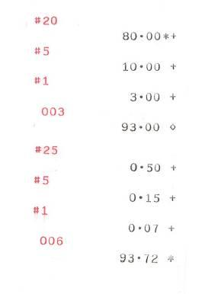
An adding machine listing each denomination (as shown here) and totaling currency and coins must be sent with the deposit.

13 CREDIT CARDS
Not applicable to student organizations.

14 TOTAL DEPOSIT
Enter the total of the amounts in items 10 through 12. This amount should agree with the total in item 9.

15 DEPOSITED BY
Treasurer’s signature and phone number.

16 ADVISOR
Advisor’s name and phone number. (Only one signature is required, but we do need 2 phone numbers in case of questions.)

DISBURSEMENT VOUCHERS

Where

Invoices to be paid should be submitted under the cover of a disbursement voucher to the University Accounting office at 304 Whitehurst. You should place the voucher in the incoming mail slot at 304 Whitehurst in the reception area. The office is open from 8:00 a.m. until 5:00 p.m. on Monday through Friday. The University Accounting office is also available to give assistance by phone. You may call during office hours at the following number: (405) 744-5881.

Procedure

You must use a disbursement voucher to process a payment through the University accounting system. These forms are available in the University Accounting office. Only one vendor/student can be paid per voucher. All invoices are to be original and itemized showing the vendor’s tax id number (F.E.I. or S.S.N.) and address. If reimbursing a student or advisor, only the Campus Wide ID (CWID) is needed. If you do not have a vendor’s F.E.I. number, then you may request the vendor to fill out a form W-9. The W-9 form can be found at www.irs.gov. Invoice date and invoice number must be clearly indicated on the front of disbursement voucher. Statements are not considered to be the original invoices and are not accepted. Purchasing requires all vendors to be added to the University database, maintained by the Purchasing Department.

Reimbursements require proof of payment and an original itemized receipt to be processed. Proof of payment may be in the form of a cash receipt, credit card receipt, or copy of a canceled check (front & back). All receipts are required to be itemized, dated, and show type/proof of payment. An itemized receipt will include the date, amount, vendor name, and itemized description of item(s) purchased. If these conditions are not met, the reimbursement will not be processed.

Assembly

After you complete the disbursement voucher, remove the gold copy for your records. The original invoice should then be attached to the disbursement voucher by placing it between the yellow and green copies and stapling through all pages (staple twice at the top of the form on each side of the title). It is important to send the original invoice with the disbursement voucher to avoid paying a bill twice. The yellow copy and the original invoice will be filed by University Accounting. The green copy will be forwarded to the vendor with the check. Vendor checks will not be returned to organizations for mailing to vendor. They will be mailed directly to the vendor. If you have something to be forwarded to the vendor with the check, attach it to the green copy of the disbursement voucher.

A check will be issued in approximately 2 to 3 weeks after the disbursement voucher has been approved by University Accounting. All of the following criteria must be met for a disbursement voucher to be approved.
1. The balance in your account must be sufficient to cover the expenditure.
2. The disbursement voucher must be signed by the Advisor and the Treasurer or President as shown on yellow signature card
3. Adequate documentation supporting the exact amount and proof of payment of the expenditure must be attached to the disbursement voucher.

Example
A copy of a blank disbursement voucher is on page 19 as an example only. Specific instructions for completing the disbursement voucher are on pages 20-21.

Record Keeping
You should keep the gold copies of all disbursement vouchers and copies of related invoices with your financial records. These items serve as supporting documentation for the disbursement vouchers recorded in your transaction register.

Additional Information
When reimbursement is to the President or Treasurer of the organization, then the voucher must be signed by the other authorized officer as shown on the signature card. You can obtain your student organization balance by calling University Accounting 744-5881 with your fund code.

The only items that may be prepaid are airfare and registrations.

If you are paying an individual for services, such as a speaker’s fee or a babysitting fee, the disbursement voucher must include the individual’s social security number and permanent address. Payment of Stipends that are not for reimbursement of expenses are considered income and will be subject to Misc 1099 reporting. If the total amount remitted to the individual exceeds $600 per calendar year, he or she will receive a Misc 1099 form from Oklahoma State University. That amount will need to be included on his or her tax return as income. Scholarships may also be taxable, but the individual will not receive a Form 1099 for them.

Also, please be aware that most student organizations are not exempt from paying sales tax on purchases. Student organizations are considered separate entities from OSU and therefore are required by the Oklahoma Tax Commission to pay sales tax on purchases. However, they may be required to charge and remit sales tax on sales and rentals involving non-exempt transactions. For questions or clarification, call University Accounting at 744-5881.

Mail To: | 1 |  |  |  |  | AGENCY FUNDS |  |  |  |  | Voucher No.
 |  |  |  |  |  | DISBURSEMENT VOUCHER |  |  |  |  | XXXXXX
Pay To: |  |  |  |  |  | Stillwater, OK 74078
FEI/SS: | 2
Both "Mail To" and "Pay To" Boxes
must be completed prior to processing |  |  |  |  |  | Date 8 | Account Name:
Address should be confined to "Mail To" Box |  |  |  |  |  | Date 8 |  |  |  | 3
Vendor#:
Account No:
 | Chart | Fund |  | Acct Code | Object Code | Sub-Activity |  |  | St. Fund | St. Agency | St. Acct:
 | 1 | 991 |  | 708950 | 5411 | 00001 |  |  | 701 | 010 | 000610
 | 4 | 5 |  | 6 | 7
QUANTITY |  | Description of Item and Invoice Number (if any ) |  |  |  |  |  |  |  | PRICE
 |  | 9 |  |  |  |  |  |  |  | 10
 |  |  |  |  |  |  |  |  |  |  |  | Date Received
 |  |  |  |  |  |  |  |  |  |  |  | in Accounting
 |  |  |  | EXAMPLE
 |  |  |  |  |  |  |  |  |  |  |  | Date
 |  |  |  |  |  |  |  |  |  |  |  | Entered
 |  |  |  |  |  |  |  |  |  | 11
 |  |  |  |  |  | phone |  |  |  | Instructions
Issued by | 12 |  |  |  |  |  | All vouchers are to be drawn in triplicate using a typewriter or a ball point pen.
 |  | Organization Treasurer |  |  |  |  | The student organization will retain the organization copy for its files. The
Approved by13 |  |  |  |  |  |  | accounting claim copy with all necessary supporting invoices or tickets
 |  | Organization President
Approved by14 |  |  |  |  |  |  | will be accompanied by the remittance copy.
 |  | Faculty Advisor
Approved by15
 |  | Controller's Office
 |  |  |  |  |  | Accounting Claim Copy

INSTRUCTIONS FOR DISBURSEMENT VOUCHER
(SUPERSEDES THE INSTRUCTIONS ON THE BACK OF THE FORM)

Use a ballpoint pen or typewriter.

1 MAIL TO
Enter the name and address of the person to whom the check is to be mailed.

2 PAY TO
Enter the name of the person or vendor to whom the check is to be issued. If you are paying a stipend to an officer of your student organization, you must include his or her Campus Wide ID number. Also, if you are paying an individual for a service, you must include his or her Social Security number and permanent address.

3 ACCOUNT NAME
Enter the name of your student organization. Do not use abbreviations or symbols such as Greek letters.

4 CHART
Enter the first number (1,…) of your 7-digit fund code.

5 FUND
Contains the last six digits of your 7-digit fund code.

6 ACCT CODE
Enter “708950”.

7 OBJECT
Enter “5411”.

8 DATE PREPARED
Enter the date the disbursement voucher was prepared.

9 DESCRIPTION OF ITEM AND INVOICE NUMBER
Enter a description of the item(s) purchased or the service rendered and the related invoice number if applicable. Your organization keeps the gold copy of the form. If you do not keep a copy of the invoice, this description will be the only documentation in your organization’s records about the expenditure. The vendor will be sent the green copy of the form. The invoice number is important to the vendor in correctly applying the payment to your account.

INSTRUCTIONS FOR DISBURSEMENT VOUCHER (cont)

10 PRICE
Enter the dollar amount of the invoice.

11 TOTAL
Enter the total amount of the listed invoices. This amount will be the same as item 10 if you are paying only one invoice.

12 ISSUED BY ORGANIZATION TREASURER
Treasurer’s signature and phone number if president does not sign. See exception*

13 APPROVED BY ORGANIZATION PRESIDENT
President’s signature and phone number if treasurer does not sign. See exception*
14 APPROVED BY FACULTY ADVISOR
Faculty advisor’s signature and phone number always.
*If paying Advisor-you will need signatures from both officers.

15 APPROVED BY CONTROLLER’S OFFICE
Leave blank. For use by University Accounting.

CAMPUS VENDOR INVOICES

Purpose

The campus vendor system facilitates the electronic transfer of funds between University departments. This system may also be utilized by student organizations to make purchases from University departments without executing a disbursement voucher.

Procedure

When you purchase goods or services from a University department, the department will complete a campus vendor invoice with instructions to charge your organization’s 7-digit fund number for the amount of the purchase. The vendor prepares the invoice. You just give the vendor your fund code. After the campus vendor invoice is processed, your advisor will receive an e-mail with the expense details. You will need to keep this e-mail for your records.

When accounting processes the invoice, the cash balance in your account will be reduced by the amount of the purchase. You are responsible for having a balance in your account sufficient to cover the purchase. The transaction will appear on your monthly accounting report (FGRODTA) as an expenditure and will reference the campus vendor invoice number. Remember to record this expenditure in your transaction register.

DO NOT SUBMIT A DISBURSEMENT VOUCHER FOR A CAMPUS VENDOR INVOICE. THIS WILL CAUSE DOUBLE PAYMENT OF THE EXPENDITURE.

Vendors

Some of the departments that utilize the campus vendor system are listed below.

O’Collegian Spears School Duplicating
HES Duplicating Student Union Bookstore
University Mailing Student Union Food Services
Facilities Mgmt work orders

Record Keeping

You should keep copies of all campus vendor invoices with your financial records. They serve as supporting documentation for the campus vendor charges on your transaction register.

PURCHASING GIFT CARDS

If the Student Organization would like to purchase gift cards, there are guidelines that must be followed:
- Approval for the purchase should be made prior to the actual purchase of the cards and should include the sponsor and officers of the organization.
- Set a limit of the total amount purchased at one time ($250) and a maximum card limit of $25 per card.
- Document information about the receiver of the gift card to include the name, address, CWID and the amount of the gift card. This information must be attached to the disbursement voucher.
- As the cards are issued, the signature of the recipient needs to be obtained and the complete log of signatures attached to the purchase documentation and the disbursement voucher.

An example of what is needed is below. If it is not complete, the reimbursement will not be processed.

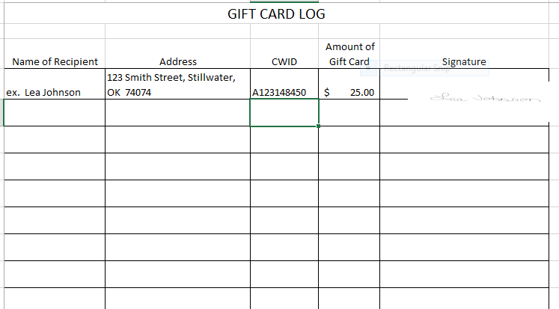

TRANSFERS

Your organization may make a payment to another student organization without processing a disbursement voucher. This transfer of funds can be initiated by submitting a memo to University Accounting at 304 Whitehurst. The memo should include the date, your organization name and fund code, the recipient organization’s name and fund code and a description and dollar amount of the expenditure. The memo should be signed by your organization’s faculty advisor and either you, as treasurer, or your president.

The above policy applies to transfers between student organizations only. Your organization cannot transfer funds to a University department by memo. Payments to a University department should be processed via a disbursement voucher or a campus vendor invoice.

DONATIONS

Any student organization receiving allocated monies through the University can not make donations with these funds. They may make a donation from money collected from other activities. Documentation is required showing the organization has deposited funds from other activities that support the donation. A memo (signed by the organization’s faculty advisor) describing the donation, payee (with address) & amount should also be attached for documentation. Voucher should be completed as described on page 20 & 21.

ACCOUNTING REPORTS

The University prepares monthly accounting reports that are available thru e-print. These reports are the Organization Detail Activity (FGRODTA), the Budget Status Report (FGRBDSC) and the Fund Account Activity Report (FGRFAAC). You need these reports to prepare your monthly account reconciliation. These reports serve as the University’s record of the transactions and current balance in your account.

FGRBDSC
The FGRBDSC provides you with summarized year-to-date information for revenues and expenses and the balance in your fund as of the end of the reporting month. Instructions for reading the FGRBDSC are on page 26. An example of an FGRBDSC is on page 27. You should note that the University operates on a June 30 fiscal year. Therefore, any year-to-date totals on this report are cumulative from July.

FGRODTA
The FGRODTA provides you with a record of the revenues and expenses recorded in your account by the University during the reporting month. You can compare the transactions recorded on the FGRODTA with the transactions recorded in your transaction register to ensure that all items were processed correctly. Instructions for reading the FGRODTA are on page 28. An example of an FGRODTA is on page 29.

FGRFAAC
The FGRFAAC is used to show your available beginning balance, your net amount (revenue – expenses) and your current month end balance. An example of an FGRFAAC is shown on page 30.

Questions

If you need copies of past reports, speak with your advisor. If your advisor does not have copies, you may call University Accounting at 744-5881 to see who in the advisor’s office can print them. If you have a question about a specific deposit or expense item on your report, contact the University Accounting office for assistance.

BUDGET STATUS REPORT
FGRBDSC

1 REPORT TITLE
The reporting month is in the middle of the page.

2 ACCOUNT ATTRIBUTES
Includes the fund and name of the student organization. Also includes the organization.

3 REVENUE SECTION
Summarizes receipts by subcode. Student organizations code all deposits to account code 500960. AFAP funds will be in account code 500140.

The “Year-End Balance Forward” which represents the balance in your account as of June 30 of the previous fiscal year that was carried forward to the current fiscal year can be found on the FGRGLTA. Your advisor can get this report.

4 EXPENSE SECTION
Summarizes expenses by account code. Student organizations code all disbursement vouchers to account code 708950. Expenses listed under other account codes have been processed through the campus vendor system.

5 ACCOUNT TOTAL
Total revenue and expenditures will net to the current year to date balance. If there is no negative sign, the amount is positive. Add it to your Year End Balance Forward to find the current balance.

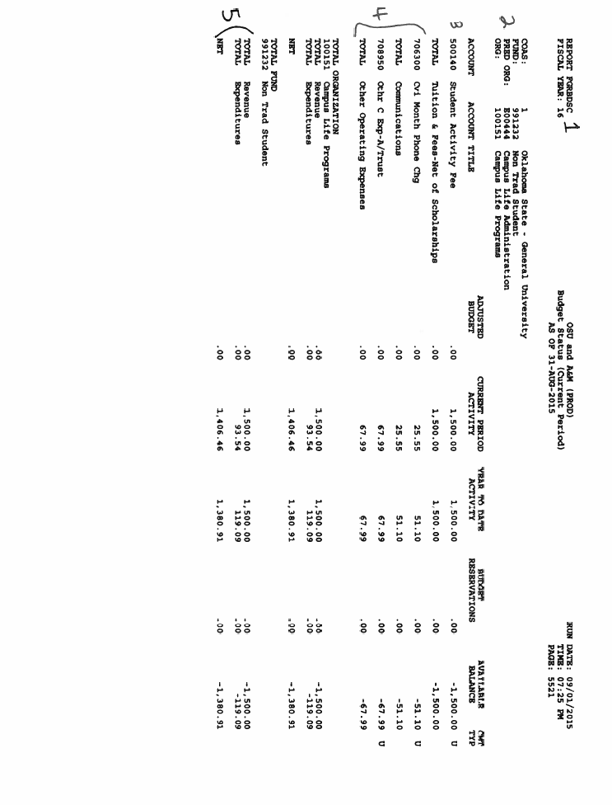
FGRODTA

1 REPORT TITLE
The reporting month is in the middle of the page.

2 ACCOUNT ATTRIBUTES
Includes the organization number and name of the student organization. The fund and the account code can be found in the middle of the page.

3 DESCRIPTION
This report lists by account code the individual transactions recorded in your fund during the reporting month. Transactions listed under account codes less than 602XXX are revenues. Transactions listed under account codes greater than 602XXX are expenses.

4 DATE
Represents the date the transaction was processed in the University’s accounting system.

5 DOCUMENT REF#
References deposit number and the Banner invoice number. The advisor can use the Document Ref # and look on SSB to find the voucher number.

6 BUDGET
Not applicable to student organizations.

7 TRANSACTION ACTIVITY
Lists the dollar amount of each transaction. The total of the transactions for each object code is summarized on the FGRBDSC.

8 TOTAL
Calculated by adding revenues and subtracting expenses. This is a total of the reporting month’s transactions only.

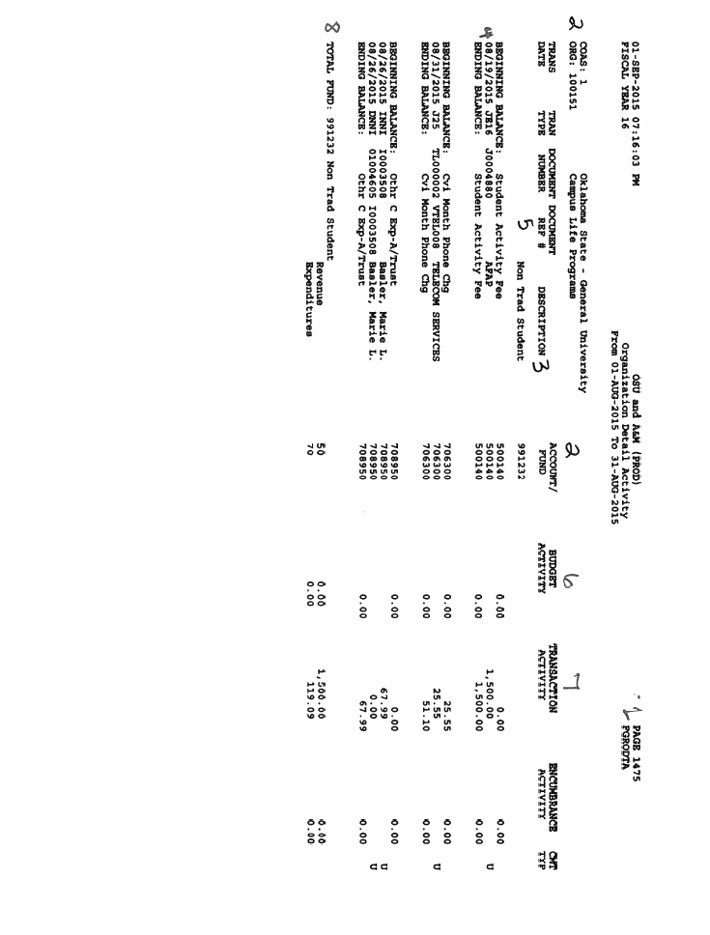
FGRFAAC

1 REPORT TITLE
The reporting month is in the middle of the page.

2 ACCOUNT ATTRIBUTES
Includes the fund and name of the student organization. The account codes can be found in the middle of the page.

3 ASSETS
The amount listed under Beginning Balance column is the beginning balance for the year, also known as the carry forward balance. The amount listed under Ending Balance is the balance as of the date of the report.

4 CONTROL ACCOUNTS
The amount listed under Ending Balance is the net amount (revenue – expenses) for the year. If there is a “-“ (minus sign) by the amount, that means the revenues are greater than the expenses.

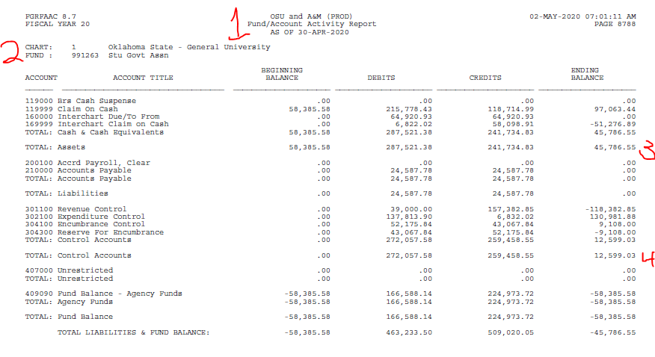

ACCOUNT RECONCILIATION

You can make certain that the balance in your account according to your organization’s records agrees to the balance in your account according to the University’s records by preparing an account reconciliation. This reconciliation compares your cash balance per your transaction register with the amount for Assets per the FGRFAAC report. These balances should be the same. Any differences can be identified and corrected on a timely basis.

Identifying Differences

Differences occur if only one party records a transaction or if each party records the same transaction at different amounts. You can identify differences by checking off the transactions in your transaction register when they appear on the FGRODTA report sent to you by the University. You should also review the FGRODTA report for transactions recorded by the University which have not been recorded by your organization.

Timing Differences

A timing difference occurs at the end of the month as a result of the time it takes for the University to process a transaction after you submit it. You record a deposit or disbursement voucher in your transaction register when you submit it for processing. If you submit the item at the end of the month, it may not be recorded in the University’s records until the following month. This creates a difference at the end of the month that will be included on your account reconciliation but will be eliminated in the following month when the University records the transaction.

Other Differences

Any other differences should be investigated by contacting the University Accounting office for assistance.

Example

The suggested format for an account reconciliation is on page 32. Specific instructions for completing the reconciliation are on pages 33-34. You should prepare an account reconciliation monthly when you receive your accounting reports from your advisor.

ACCOUNT RECONCILIATION
 |  | 1 |  |  |  |  |  |  | 2
(Organization Name) |  |  |  |  |  |  |  | (Fund Code)
Account balance per the University from the
FGRFAAC report date 3
 |  |  |  |  |  |  |  |  |  | $ 4
PLUS: Deposits on the organization's transaction register not yet recorded by the University on the FGRODTA report.
Date | Number |  | Amount
 |  | $
 |  |  |  |  |  | 5
 |  |  |  |  |  | Total + |  | $ - |  | 6
Minus: Expenses on the organization's transaction register not yet recorded by the University on the FGRODTA report.
Date | Number |  | Amount
 |  | $
 |  |  |  |  |  | 7
 |  |  |  |  |  | Total - |  | $ - |  | 8
Other Items:
 |  |  |  |  |  |  |  | $ -
 |  |  |  |  |  | 9 |  | $ - |  | 10
 |  |  |  |  |  |  |  | $ -
Net adjustments to University's balance |  |  |  |  |  |  |  |  |  | $ 11
Adjusted account balance per the University |  |  |  |  |  |  |  |  |  | $ 12
Account balance per the organization from the
transaction register dated 14 |  |  |  |  |  |  |  |  |  | $ 13
* The adjusted account balance per the University must equal the account balance per the organization
Treasurer's Signature______________________. |  |  |  |  |  |  | Date Prepared__________

INSTRUCTIONS FOR ACCOUNT RECONCILIATION

1 ORGANIZATION NAME
Enter the name of your student organization.

2 FUND CODE
Enter the 7-digit account number of your organization.

3 FGRFAAC REPORT DATE
Enter the date in the title of the FGRFAAC report prepared by the University.

4 ACCOUNT BALANCE PER THE UNIVERSITY
Enter the balance from the FGRFAAC report found under the column “Ending Balance” and the row titled “Assets”.

5 LIST OF DEPOSITS
Enter the date, reference number and dollar amount of any deposits on your organization’s transaction register not yet recorded by the University on the FGRODTA report.

6 TOTAL DEPOSITS
Enter the total of the deposits listed in item 5.

7 LIST OF EXPENSES
Enter the date, reference number and dollar amount of any expenses (i.e. disbursement vouchers, campus vendor invoices) on your organization’s transaction register not yet recorded by the University on the FGRODTA report.

8 TOTAL EXPENSES
Enter the total of the expenses listed in item 7.

9 OTHER ITEMS
Enter a description of any items recorded improperly by the University on the FGRODTA report.

10 OTHER ITEMS $
Enter the dollar amount of any items recorded improperly by the University on the FGRODTA report.

11 NET ADJUSTMENTS TO THE UNIVERSITY BALANCE
Subtract the item 8 total from the item 6 total; add any expenses listed under item 10; subtract any deposits listed under item 10.

INSTRUCTIONS FOR ACCOUNT RECONCILIATION

12 ADJUSTED ACCOUNT BALANCE PER THE UNIVERSITY
Add the item 11 total to the balance in item 4.

13 ACCOUNT BALANCE PER THE ORGANIZATION
Enter the organization’s ending transaction register balance.

14 TRANSACTION REGISTER DATE
Enter the date of the balance in item 13 above.

REVIEW BY INTERNAL AUDIT

The Department of Internal Audits of the OSU and A&M Board of Regents will review the records of student organizations that receive funds allocated by the Student Government Association upon request.

The purpose of the review is to determine that the organization is maintaining an accurate and complete set of financial records. Internal Audit will review the following records to make this determination. These records should be submitted to the Internal Audit office at 301 Whitehursth.

1. The ledger sheet showing the debits and credits to your account with the cumulative cash balance.

2. Documentation supporting the entries to the ledger sheet such as deposit receipts, invoices/disbursement vouchers and campus vendor invoices.

3. The monthly accounting reports provided to you by the University (FGRODTA and FGRFAAAC).

4. The reconciliation between the organization’s ledger and the University’s records.

Your organization will be notified by Internal Audit when their review is complete. A memorandum to report the results of the review will be issued to the organization with copies sent to the organization’s faculty advisor and the Manager of Campus Life. You will receive the memorandum when you pick up your records.

The review performed by Internal Audit is not a financial audit. Requests for a full audit, if necessary, can be made to the Director of Internal Audits by your faculty advisor or any University administrator. An audit would require a more extensive examination of your financial records.

You can contact the Department of Internal Audits at 744-6100.

PURCHASING CARD FOR STUDENT ORGANIZATIONS

A purchasing card is available for Student Organizations with ledger 9 funds.

For more information contact:

Purchasing Card Administrator
Fiscal and Administrative Compliance
1224 North Boomer Road
Stillwater, OK 74078-1028
405-744-8408

